MySQL Assignment 1 – DDL Commands & Constraints
Fathima resmin f(69)
Employee Database schema:
1.Table Creation (CREATE): Write the SQL statements to create a database named “employee” and the following tables based on the provided schema:
⦿ Departments ⦿ Location ⦿ Employees
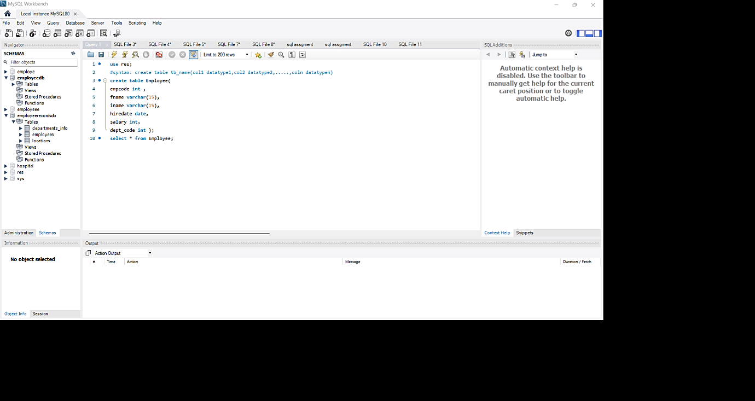

2.Table Alteration (ALTER): Consider the following scenarios and write the SQL statements to alter the structure of the tables accordingly:
Add a new column named "email" to the Employees table to store employee email addresses.
-ALTER TABLE employees
ADD COLUMN email VARCHAR(100);
SELECT * FROM employees;

?Modify the data type of the "designation" column in the Employees table to support a wider
Range of value
-ALTER TABLE employees
MODIFY COLUMN designation VARCHAR(150);
SELECT * FROM employees;

?Drop the “age” column from the Employees table.
ALTER TABLE employees
DROP CHECK chk_employee_age;
ALTER TABLE employees
DROP COLUMN age;SELECT * FROM employees;
? Rename the “hire_date” column to “date_of_joining”
ALTER TABLE employees
RENAME COLUMN hire_date TO date_of_joining;
SELECT * FROM employees;

3. Table Renaming (RENAME): Rewrite the SQL statements to rename the following tables:

? Rename the "Departments" table to "Departments_Info".
RENAME TABLE departments TO Departments_Info;
SELECT * FROM Departments_Info;

? Rename the "Location" table to "Locations".
RENAME TABLE location TO Locations;
SELECT * FROM Locations;

4. Table Truncation (TRUNCATE): Write an SQL statement to truncate the Employees table.
TRUNCATE TABLE employees;
SELECT * FROM employees;

5. Database & Table Dropping (DROP): Write the SQL statements to drop the Employees table and then the “employee” database.
DROP TABLE IF EXISTS employees;
DROP DATABASE IF EXISTS EmployeeRecordsDB;

Constraints :
- Database Recreation:
? Drop the 'employee' database if it exists and recreate it using the provided schema, ensuring that all tables are created with the appropriate constraints as instructed.
DROP DATABASE IF EXISTS EmployeeRecordsDB;
CREATE DATABASE EmployeeRecordsDB;
USE EmployeeRecordsDB;
- Departments Table:

? Ensure that the "department_id" uniquely identifies each department.
CREATE TABLE departments (
department_id INT PRIMARY KEY,
department_name VARCHAR(100) NOT NULL UNIQUE
);
SELECT * FROM departments;

? Set up constraints on the "department_name" to avoid duplicate and null
department_name
VARCHAR(100) NOT NULL UNIQUE

- Location Table:
? Establish a mechanism to automatically generate unique identifiers for each location, ensuring that they are incremented sequentially
?Implement constraints to prevent the insertion of null and duplicate locations.
location_id
INT PRIMARY KEY AUTO_INCREMENT
location VARCHAR(30) NOT NULL UNIQUE

- Employees Table:
? Guarantee that each employee has a distinct identifier.
PRIMARY employee_id INT KEY
? Create a restriction to ensure that the employee's name is always provided.
employee_name VARCHAR(50) NOT NULL
? Limit the acceptable values for the "gender" field to only 'M' or 'F'.
gender ENUM('M', 'F') NOT NULL
? Enforce a condition to ensure that the employee's age is 18 or above.
CONSTRAINT chk_employee_age CHECK (age >= 18)
? Automatically assign the current date to the "hire_date" field if not specified.
hire_date DATE DEFAULT (CURRENT_DATE)

?Establish links between the "department_id" and "location_id" fields in the "employees" table and their respective tables.
CONSTRAINT fk_department
FOREIGN KEY (department_id)
REFERENCES departments(department_id)

CONSTRAINT fk_location
FOREIGN KEY (location_id)
REFERENCES location(location_id)

EMPLOYEE TABLE CODE
DROP DATABASE IF EXISTS EmployeeRecordsDB;

CREATE DATABASE EmployeeRecordsDB;

USE EmployeeRecordsDB;

CREATE TABLE departments (
department_id INT PRIMARY KEY,
department_name VARCHAR(100) NOT NULL UNIQUE
);

SELECT * FROM departments;

INSERT INTO departments (department_id, department_name)
VALUES
(101, 'HR'),
(102, 'Software'),
(103, 'Finance');

SELECT * FROM departments;
CREATE TABLE location (
location_id INT PRIMARY KEY AUTO_INCREMENT,
location VARCHAR(30) NOT NULL UNIQUE

SELECT * FROM location;
INSERT INTO location (location)
VALUES
('Kochi'),
('Calicut'),
('Trivandrum');
SELECT * FROM location;
CREATE TABLE employees (
employee_id INT PRIMARY KEY,
employee_name VARCHAR(50) NOT NULL,
gender ENUM('M', 'F') NOT NULL,
age INT NOT NULL,
hire_date DATE DEFAULT (CURRENT_DATE),
designation VARCHAR(100),
department_id INT,
location_id INT,
salary DECIMAL(10,2),
CONSTRAINT chk_employee_age CHECK (age >= 18),
CONSTRAINT fk_department
FOREIGN KEY (department_id)
REFERENCES departments(department_id),
CONSTRAINT fk_location
FOREIGN KEY (location_id)
REFERENCES location(location_id)
);

SELECT * FROM employees;
INSERT INTO employees
(employee_id, employee_name, gender, age, hire_date,
designation, department_id, location_id, salary)
VALUES
(1, 'Rahul Sharma', 'M', 28, '2024-01-15',
'Software Engineer', 102, 3, 45000.00),
(2, 'Priya Nair', 'F', 32, '2023-06-10',
'HR Manager', 101, 1, 55000.00),
(3, 'John Smith', 'M', 40, '2022-03-20',
'Financial Analyst', 103, 2, 60000.00);
SELECT * FROM employees;
INSERT INTO employees
(employee_id, employee_name, gender, age, designation,
department_id, location_id, salary)
VALUES
(4, 'Anu Thomas', 'F', 25, 'HR Executive',
101, 1, 35000.00);
SELECT * FROM employees;

SELECT * FROM employees
WHERE age >= 18;
SELECT * FROM employees
WHERE gender = 'M';

SELECT * FROM employees
WHERE gender = 'F';

SELECT * FROM employees
WHERE age >= 30;

SELECT * FROM employees
WHERE department_id = 102;

SELECT * FROM employees
WHERE location_id = 1;

ALTER TABLE employees
ADD COLUMN email VARCHAR(100);

SELECT * FROM employees;

UPDATE employees
SET email = 'rahul@gmail.com'
WHERE employee_id = 1;

UPDATE employees
SET email = 'priya@gmail.com'
WHERE employee_id = 2;

UPDATE employees
SET email = 'john@gmail.com'
WHERE employee_id = 3;

UPDATE employees
SET email = 'anu@gmail.com'
WHERE employee_id = 4;

SELECT * FROM employees;
ALTER TABLE employees
MODIFY COLUMN designation VARCHAR(150);

SELECT * FROM employees;
ALTER TABLE employees
RENAME COLUMN hire_date TO date_of_joining;

SELECT * FROM employees;
SELECT * FROM departments;
RENAME TABLE departments TO Departments_Info;

SELECT * FROM Departments_Info;
SELECT * FROM location;

RENAME TABLE location TO Locations;
SELECT * FROM Locations;

SELECT * FROM employees;
ALTER TABLE employees
DROP CHECK chk_employee_age;

SELECT * FROM employees;

ALTER TABLE employees
DROP COLUMN age;
SELECT * FROM employees;

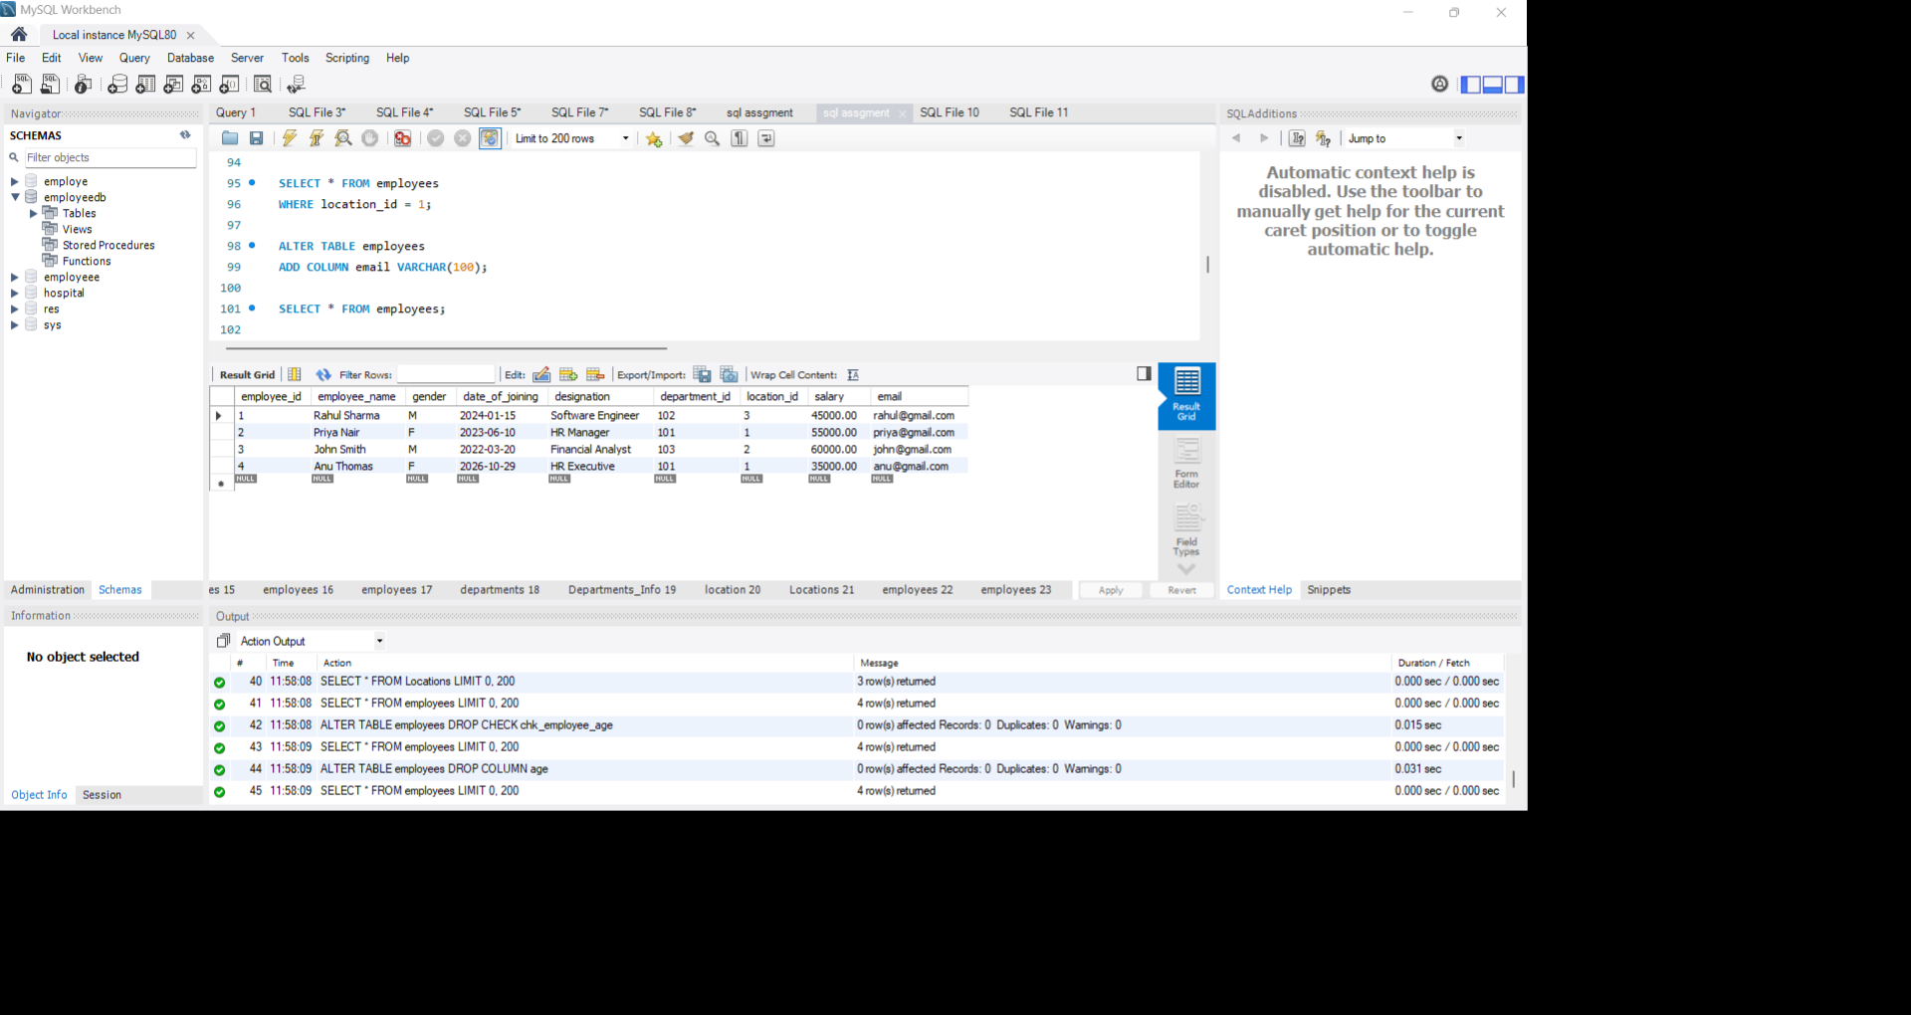
OUTPUT

